Project Report Template

1. INTRODUCTION
   1. Overview

The HR scorecard is meant to measure leading HR indicators of business performance. Leading indicators are measurements that predict future business growth. These are called HR deliverables. They are also known as HR metrics, and more specifically HR KPIs, as they are metrics that are linked to the business strategy. An HR Scorecard is a tool that helps a company use its human resources strategically and prove how HR contributes to financial success. The scorecard measures HR deliverables, metrics, and KPIs that help companies assess and foresee organizational growth and development. Disadvandages of an HR balanced scorecard While there are so many benefits to deploying an HR scorecard, there are potential roadblocks you should be aware of Even though there are many HR scorecard templates you can use, the framework must be customized to suit your business requirements. This can be time-consuming and tedious - especially for first-time users.HR scorecards can be overly complicated to understand despite there being many case studies and resources to read from.

* 1. Purpose

Real-life examples of talent management happen every day. Consider, for instance, an apparel retailer that wants to transition its business model from simply supplying clothes to delivering customers a truly service-based experience. To achieve this goal, the organization’s leaders know they will need a new breed of associates and managers. They therefore implement assessment and applicant tracking tools to help them hire the right candidates and use real-time performance data to give supervisors the insights they need to make smarter decisions. The HR function has evolved over the years, from a mere administrative function tasked with payroll and other similar work to becoming key in determining an organization’s approach and strategy. It is vital to understand how effective this function is in executing tasks, and the HR Scorecard gives management insights into the HR department’s success or failures.

1. Problem Definition & Design Thinking

* Empathy Map

Key elements of HR scorecard:

* The first element is what we called workforce success. The second element is called we called Right HR costs.
* The Third element we describe as Right Types if HR Alignment. The fourth element is Right HR practice and fifth element is Right HR professionals.

HR Dashboard:

* An HR Dashboard is a business intelligence tool that allows Human Resources teams to tracks, analayze and report on HR KPIs.
* Modern, interactive dashboards leverage an HR analytics platfrom which makes it easy to combine data form all systes and to deeply explore this data directly within the dashboard.

Full Form Of KPI In HR:

* KPI stands for key performance indicator a quantifiable measure of performance over tome for a specific objective.
* KPIs provide targets for teams to shoot for, milestones to gauge progress and insights that help people across the organization make better decision.

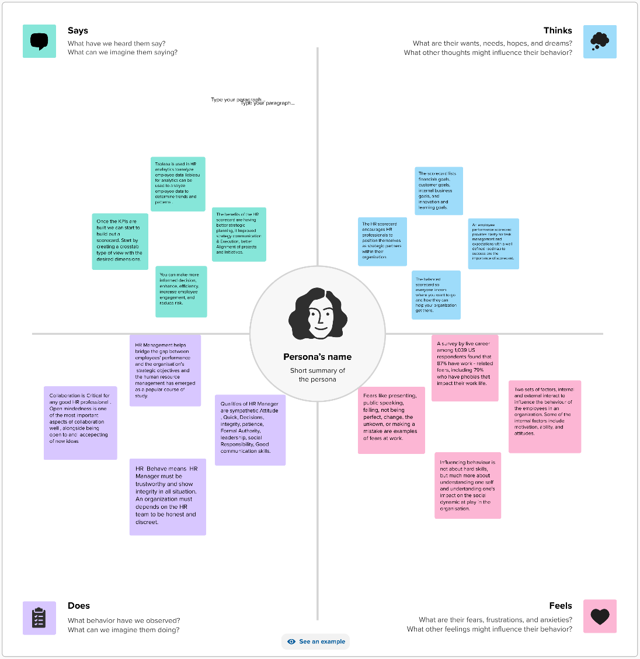

* 2.2 Brainstorming Map

Measures Used in HR Scorecard:

* An HR Scorecard visually represent the critical measures of the HR department’s achievements, productivity levels.
* Other parameters- such as hiring costs, retention rate, time to fill, quality of hire, and so on- critical to the company’s growth.

Talent Management Success Indicators:

* Employee Engagement.
* Leadership Development.
* Borad Development.
* Employee/Clinical supervision.
* Organization Culture.
* Cultural Competency.
* Professional Ethics.

Talent Success:

* Talent Success by consistenly deploying more A plyers against your company’s goals than your competitors.
* Doing so involves a framework that enable HR and Talent Management to align and benchmark their organizations’ talent to power the company’s mission vision and goals.

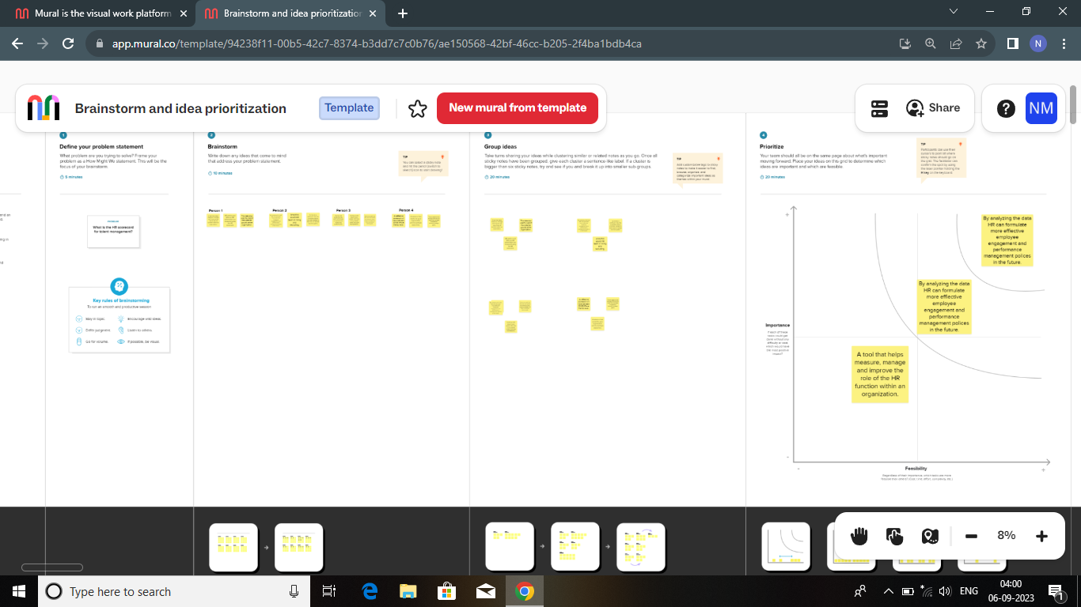

1. Result:

Story: 1

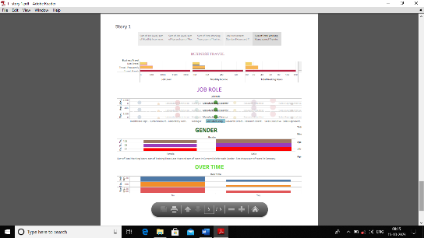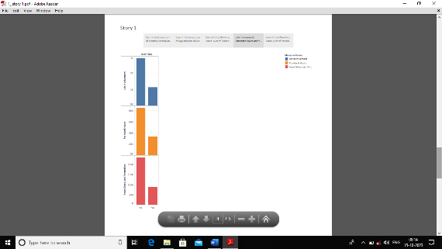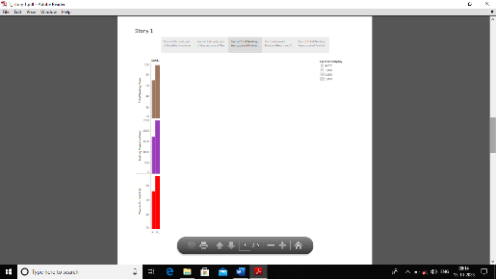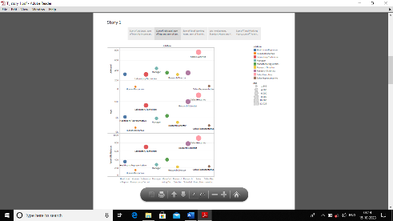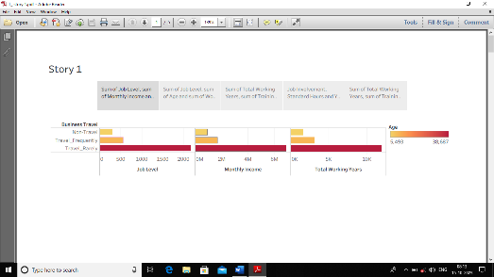

Story: 2

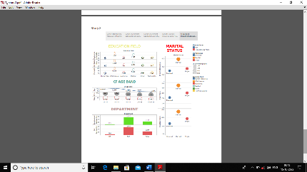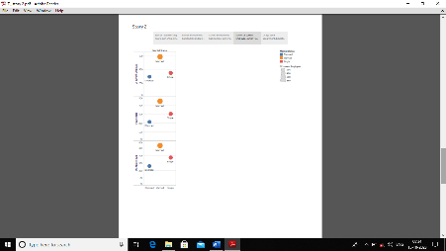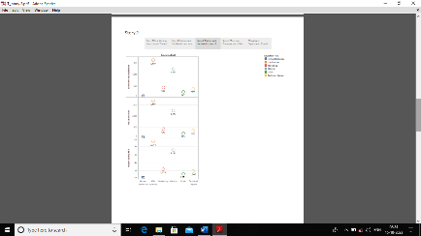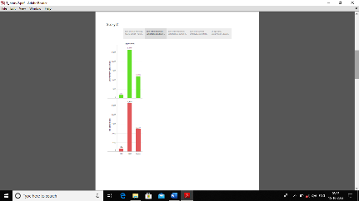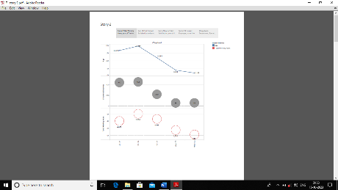

4 Advantages & Disadvantages:

* Advantages:
* Effective scorecards link performance to the organization overall performance and goals.
* This linkage can help in communicating performance and results to the various stakeholders. A well-designed and balanced scorecard with solid supplementary processes will help increase accountability.
* Disadvantages:
* One of the disadvantages of the HR scorecard is that measuring intangibles is difficult, if not impossible, a degree of subjectivity on the part of Hr staff.
* Subjectivity undermines the validity of data and, therefore, limits the credibility of HR and its ability to prove its worth to an organization.

1. Applications:

* The HR scorecard is meant to measure leading HR indicators of business performance.
* Leading indicators are measurements that predict future business growth.
* These are called HR deliverables. They are also known as HR metrics, and more specifically HR KPls, as they metrics that are linked to the business strategy.

1. Conclusion:

* As the name denotes, balanced scorecard creates a ring balance between the components of organization objectives and vision.
* The balanced scorecard focuses attention not only on the financial attention not only on the financial objectives of the company but also highlights the non- financial objective that on organization must achieve in order to meet its financial objectives.

1. Future Scope:

* The future of HR has completely transformed post-pandemic. With rise of remote working, AR/ VR technologies, metaverse and now generative AI, the HR profession will fundamentally reshape into a key cog in the wheel for workplace.
* How should HR professionals prepare for the future? What kind of HR jobs will be there in the future? We spoke to some of the global award-winning HR leaders to find out. Today I present Asanify’s findings on how key HR trends will impact the future of HR. I will look at the following periods:
* 2023: Right now
* 2025: HR Management in a few years
* 2030: Human resources many years into the future.
* The change in HR workings will also have an impact on the future of work itself. Read on to learn how the future will impact all of us. And be ready to be surprised